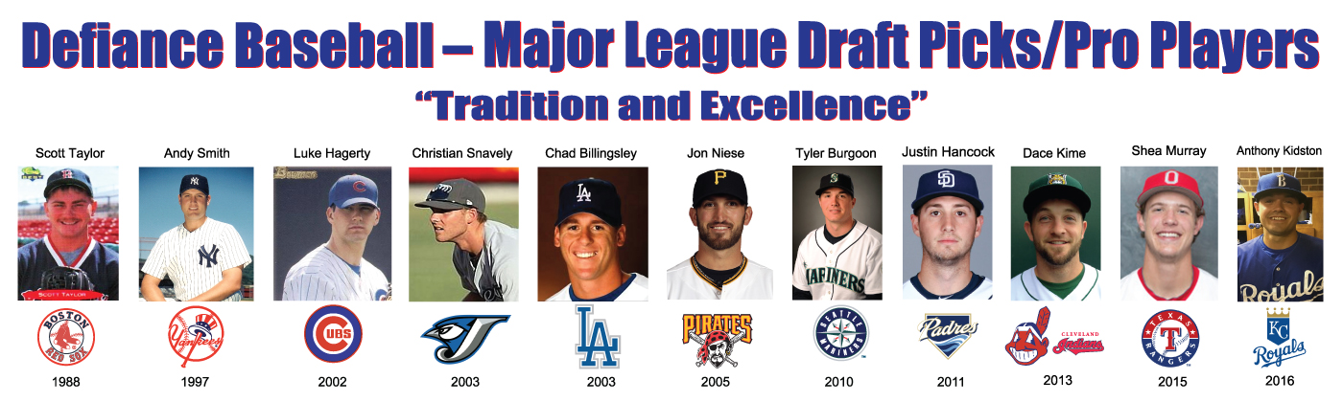
February, 19

To Whom It May Concern:

As winter begins to fade the Defiance High School Baseball & Softball teams are preparing for the upcoming spring season. Traditionally successful, we are looking forward to the 2019 campaign. Part of our success can be attributed to our ability to purchase needed equipment for the spring and summer programs. In order to do that, we need to generate additional funds beyond that which we receive through the school.
- 1 year – Includes cost of sign and placement for one year. $300.00
- 2 year – Includes cost of sign and placement for two years. $400.00
- 3 year – Includes cost of sign and placement for three years. $550.00
- 4 year – Includes cost of sign and placement for four years. $675.00
Due to our competitive schedules and the fine quality of our venues we attract fans from throughout Defiance county and the surrounding area. Through this program you not only help support our players and programs you “sell “ your company or organization to the public.
Utilize the enclosed order form and we will get you started in the program today!
If you have any questions about our program please do not hesitate to email Tom Held at theld@defianceschools.net.
Thank you in advance for your support and we look forward to seeing you at the games!

Thank you,

Tom Held,
Defiance Baseball

